**Title of your contribution to JSI2025 (Arial,12pt, bold)**

A. Author1, Presenting Author1, C. Author1 and (Arial 11pt). Bob1

1*Laboratory of wonderful experiments, University of Elsewhere, City, Country*

*2Even Better Labs, University of the Otherside, City, Country*

*(Arial 10pt, Italic)*

*corresponding author: a.author@elsewhere.fr

Please us this template to prepare your contribution to JSI2025, Saclay. Main text is Arial 10pt, and references should be inserted at the end of the abstract, and refered to in the main text using [1]. You can insert a figure below with a short caption (Arial 9pt). Margins should be 3 cm (Top), 2.5 cm (bottom), and 2 cm (right and left) [2].

The abstract should not exceed one page, including references and figure.

When submitting your contribution, independent of the type of contribution, the “presenting author“ will always be named “speaker” on the web-interface.

Abstracts must be uploaded as .doc files.

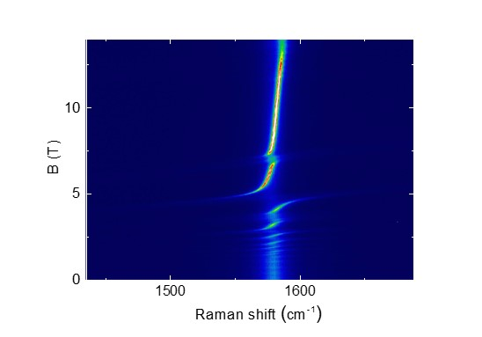

Fig.1. At maximum one figure of 7 cm width can be placed in the abstract with a short caption. (9 point, Arial)

[1] A. Author, B. Author, and C. Author, Phys. Rev. B **100**, 100001 (2021).

[2] The right is usually at the left of the other one and we here follow this tradition.